X-ray crystallography (XRC) is the experimental science determining the atomic and molecular structure of a crystal, in which the crystalline structure causes a beam of incident X-rays to diffract into many specific directions. By measuring the angles and intensities of these diffracted beams, a three-dimensional picture of the density of electrons within the crystal can be produced. From this electron density, the mean positions of the atoms in the crystal can be determined, as well as their chemical bonds, their crystallographic disorder, and various other information. Since many materials can form crystals—such as salts, metals, minerals, semiconductors, as well as various inorganic, organic, and biological molecules—X-ray crystallography has been fundamental in the development of many scientific fields. This method determines the size of atoms, the lengths and types of chemical bonds, and the atomic-scale differences among various materials, especially minerals and alloys. The method also reveals the structure and function of many biological molecules, including vitamins, drugs, proteins and nucleic acids such as DNA. X-ray crystallography is still the primary method for characterizing the atomic structure of new materials. X-ray crystal structures can also account for unusual electronic or elastic properties of a material, shed light on chemical interactions and processes, or serve as the basis for designing pharmaceuticals against diseases.
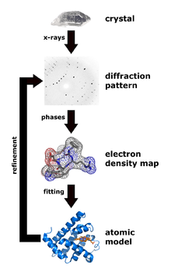
Workflow for solving the structure of a molecule by X-ray crystallography
Crystals are regular arrays of atoms, and X-rays can be considered waves of electromagnetic radiation. Atoms scatter X-ray waves, primarily through the atoms' electrons. This phenomenon is known as elastic scattering, and the electron is known as the scatterer. A regular array of scatterers produces a regular array of spherical waves. Although these waves cancel one another out in most directions through destructive interference, they add constructively in a few specific directions, determined by Bragg's law (English physicists Sir W.H. Bragg and his son Sir W.L. Bragg developed the relationship in 1913):
n λ=2dsinθ
where the crystals appear to reflect X-ray beams at certain angles of incidence (theta, θ). The variable d is the distance between atomic layers in a crystal, and the variable lambda λ is the wavelength of the incident X-ray beam; n is an integer.
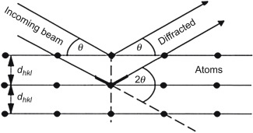

The atomic planes of a crystal cause an incident beam of X-rays to interfere with one another as they leave the crystal. The phenomenon is called X-ray diffraction. XRD (X-ray diffraction) is a technique that helps to
- measure the average spacings between layers or rows of atoms
- determine the orientation of a single crystal or grain
- find the crystal structure of an unknown material
- measure the size, shape and internal stress of small crystalline regions
In X-ray diffraction methods, the scattering is elastic; the scattered X-rays have the same wavelength as the incoming X-ray. X-rays are used to produce the diffraction pattern because their wavelength λ is typically the same order of magnitude (1–100 angstroms) as the spacing d between planes in the crystal.
Single-crystal X-ray diffraction
The oldest and most precise method of X-ray crystallography is single-crystal X-ray diffraction, in which a beam of X-rays strikes a single crystal, producing scattered beams. When they land on a piece of film or other detector, these beams make a diffraction pattern of spots; the strengths and angles of these beams are recorded as the crystal is gradually rotated. Each spot is called a reflection, since it corresponds to the reflection of the X-rays from one set of evenly spaced planes within the crystal. For single crystals of sufficient purity and regularity, X-ray diffraction data can determine the mean chemical bond lengths and angles to within a few thousandths of an angstrom and to within a few tenths of a degree, respectively. The atoms in a crystal are not static, but oscillate about their mean positions, usually by less than a few tenths of an angstrom. X-ray crystallography allows measuring the size of these oscillations.
In a single-crystal X-ray diffraction measurement, a crystal is mounted on a goniometer. The goniometer is used to position the crystal at selected orientations. The crystal is illuminated with a finely focused monochromatic beam of X-rays, producing a diffraction pattern of regularly spaced spots known as reflections. The two-dimensional images taken at different orientations are converted into a three-dimensional model of the density of electrons within the crystal using the mathematical method of Fourier transforms, combined with chemical data known for the sample. Poor resolution (fuzziness) or even errors may result if the crystals are too small, or not uniform enough in their internal makeup.
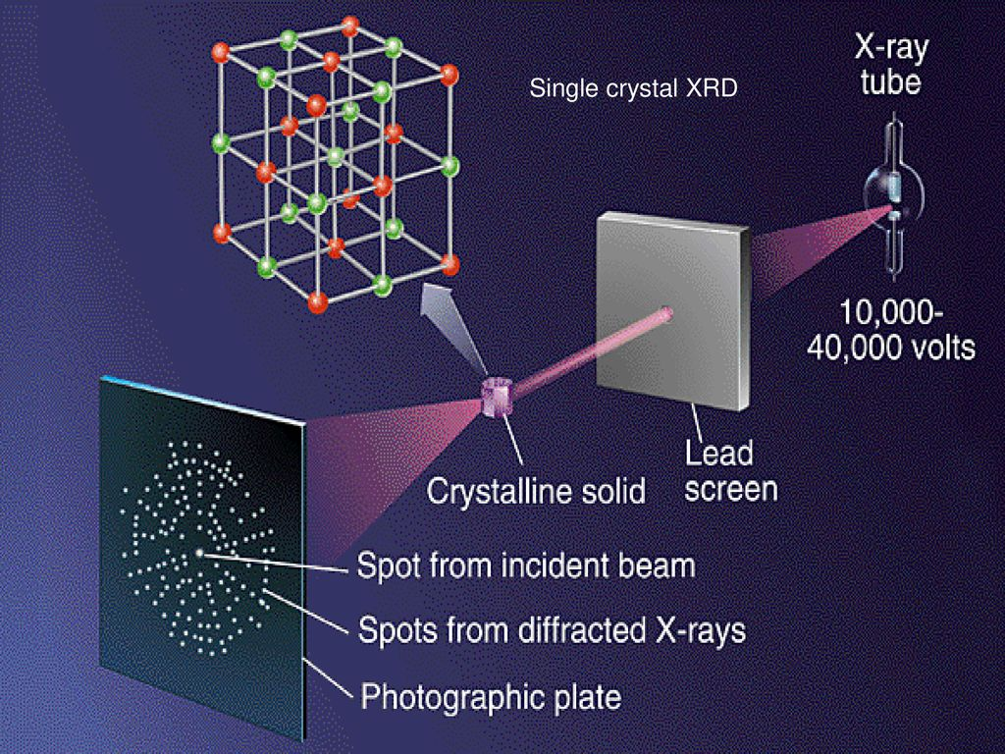
X-ray powder diffraction (XRD)
In powder X-ray diffraction, the diffraction pattern is obtained from a powder of the material, rather than an individual crystal. Powder diffraction is often easier and more convenient than single crystal diffraction since it does not require individual crystals be made. Powder X-ray diffraction (XRD) also obtains a diffraction pattern for the bulk material of a crystalline solid, rather than of a single crystal, which doesn't necessarily represent the overall material. A diffraction pattern plots intensity against the angle of the detector, 2θ (XRD pattern given below).
X-ray powder diffraction (XRD) is a rapid, nondestructive analysis of multicomponent mixtures without the need for extensive sample preparation. XRD has ability to quickly analyze unknown materials and performs material characterization in such fields as metallurgy, mineralogy, forensic science, archeology, condensed matter physics, and the biological and pharmaceutical sciences. This method provides information on phase identification, crystallinity, lattice parameters. Various kinds of microcrystalline materials may be characterized from X-ray powder diffraction, such as inorganic, organic and pharmaceutical compounds, minerals, catalysts, metals and ceramics. Since most materials have unique diffraction patterns, compounds can be identified by using a database of diffraction patterns (the available literature). The purity of a sample can also be determined from its diffraction pattern, as well as the composition of any impurities present. The particle size of the powder can also be determined by using the Scherrer formula, which relates the particle size to the peak width. The Scherrer formula is:
$$D_{v }=Kλ/(βcosθ)$$
where$D_{v }$= Crystallite size; K = Scherrer constant (value between 0.9-1.0); λ = wavelength of the x-ray; β = width of the longest peak in XRD graph e.g. as given below; θ = Bragg angle for the longest peak at 2θ.

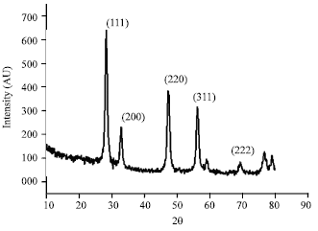
XRD pattern of Cesium oxide nanoparticles

